Capital Asset Pricing Model (CAPM)

1. Meaning of CAPM
The Capital Asset Pricing Model (CAPM) explains the relationship between expected return and systematic risk (beta) of a security.
It states that investors are compensated only for systematic risk, since unsystematic risk can be eliminated through diversification.

CAPM Formula:
E(Ri)=Rf+βi(Rm−Rf)
Where:
- E(Ri) = Expected return on security i
- Rf = Risk-free rate of return
- βi​ = Beta of security i
- Rm​ = Expected market return
- (Rm−Rf) = Market risk premium

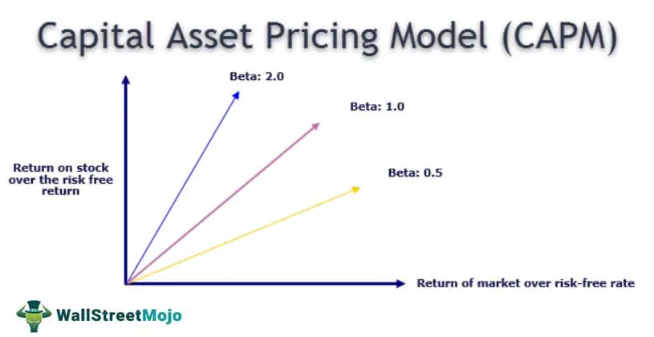2. Assumptions of CAPM

1. Rational Investors
- Investors are rational and aim to maximize returns for a given level of risk.
- They prefer higher returns and lower risk.

2. Risk is Measured by Variance or Standard Deviation
- Investors evaluate risk based on variance or standard deviation of returns.
- Expected return and risk are the only factors considered in investment decisions.

3. Investors Hold Diversified Portfolios
- Investors hold well-diversified portfolios.
- Hence, unsystematic risk is completely eliminated.
- Only systematic risk (beta) remains relevant.

4. Homogeneous Expectations
- All investors have identical expectations about:
  - Expected returns
  - Risk
  - Correlation among securities
- As a result, everyone identifies the same market portfolio.

5. Existence of a Risk-Free Asset
- A risk-free asset is available.
- Investors can borrow and lend unlimited amounts at the same risk-free rate.

6. Perfect Capital Market
- No taxes
- No transaction costs
- No flotation costs
- Securities are infinitely divisible

7. Single-Period Investment Horizon
- All investors plan for the same single holding period.
- Decisions are based on one-period returns.

8. Securities are Marketable and Liquid
- All securities are freely traded in the market.
- Information is freely and instantly available to all investors.

3. Applications of CAPM

1. Estimation of Expected Return
- CAPM helps calculate the required or expected rate of return on a security.
Widely used by investors and analysts for decision-making.

2. Security Valuation
- Used to determine whether a security is overvalued or undervalued:
  - If actual return > CAPM return → Undervalued
  - If actual return < CAPM return → Overvalued

3. Portfolio Selection
- Helps investors choose securities based on beta.
- Assists in constructing portfolios aligned with risk preference.

4. Cost of Equity Capital
- Firms use CAPM to estimate cost of equity:
Ke=Rf+β(Rm−Rf)
- Important for capital budgeting and financial planning.

5. Capital Budgeting Decisions
- Used as a discount rate for evaluating investment projects.
- Projects with returns higher than CAPM return are accepted.

6. Performance Evaluation
- Helps evaluate portfolio performance by comparing:
  - Actual return vs CAPM expected return
- Basis for measures like Jensen’s Alpha.

7. Risk Analysis
- Separates systematic risk from unsystematic risk.
- Helps managers focus on market-related risk factors.

8. Pricing of Risk
- Explains how risk is priced in the capital market.
- Establishes a linear relationship between risk (β) and return.

Merits (Advantages) of CAPM

1. Simple and Easy to Understand
CAPM provides a very simple relationship between risk and return.
- Investors can easily calculate expected return using:
E(Ri)=Rf+β(E(Rm)−Rf)
- It helps in understanding that higher risk → higher return.

2. Useful in Estimating Expected Return
CAPM is widely used to estimate the required return on equity shares.
- Helps investors know whether a stock is giving sufficient return for its risk level.
- Useful in comparing different investment alternatives.

3. Helps in Portfolio Diversification
CAPM emphasizes that:
- Only systematic risk (market risk) matters.
- Unsystematic risk can be eliminated through diversification.
Thus, investors focus on market-related risk rather than company-specific risk.

4. Provides a Benchmark for Performance Evaluation
CAPM is used to evaluate whether a portfolio or stock is performing well.
- If actual return > CAPM return → investment is undervalued.
- If actual return < CAPM return → investment is overvalued.
Used in Jensen’s Alpha performance measure.

5. Useful for Cost of Equity Calculation
CAPM is widely used by companies to calculate the cost of equity for:
- Capital budgeting decisions
- Valuation of firms
- Estimation of WACC (Weighted Average Cost of Capital)

6. Establishes Risk–Return Trade-Off
CAPM clearly explains the relationship between:
- Risk (Beta)
- Return (Expected return)
It shows that investors should be compensated only for market risk.

7. Helps in Pricing Securities
CAPM helps in determining whether a security is correctly priced in the market.
- Overpriced securities lie below the Security Market Line (SML)
- Underpriced securities lie above the SML

8. Theoretical Foundation for Modern Finance
CAPM forms the basis for many advanced financial models such as:
- Arbitrage Pricing Theory (APT)
- Multi-factor models
- Portfolio optimization models

9. Applicable for Large Market Portfolios
CAPM is very useful for investors dealing with diversified portfolios such as:
- Mutual funds
- Index funds
- Pension funds

10. Supports Rational Investment Decisions
It helps investors make informed decisions based on:
- Risk-free rate
- Market return
- Beta of the asset
Thus, investment choices become more scientific.

❌ Demerits (Limitations) of CAPM

1. Unrealistic Assumptions
CAPM is based on many assumptions that do not hold true in reality, such as:
- Investors are rational
- No taxes or transaction costs
- Perfect capital markets
- Unlimited borrowing/lending at risk-free rate
These assumptions reduce practical accuracy.

2. Beta is Not Stable
CAPM relies heavily on Beta, but:
- Beta changes over time
- Past Beta may not predict future risk accurately
Thus, expected return estimation may be unreliable.

3. Ignores Unsystematic Risk Completely
CAPM assumes investors hold fully diversified portfolios, so unsystematic risk is ignored.
However, in reality:
- Many investors hold limited stocks
- Company-specific risk may still affect returns

4. Difficulty in Identifying the Market Portfolio
CAPM assumes existence of a true market portfolio including:
- Stocks
- Bonds
- Real estate
- Commodities
But practically, it is impossible to measure the complete market portfolio.

5. Risk-Free Rate is Not Constant
CAPM assumes a constant risk-free return, but:
- Interest rates fluctuate
- Government securities yield changes over time
This affects expected return calculation.

6. Market Returns are Difficult to Predict
CAPM uses expected market return, but:
- Market returns are uncertain
- Forecasting is difficult
This reduces model accuracy.

7. Single Factor Model
CAPM considers only one factor: market risk (Beta).
But in reality, returns depend on multiple factors such as:
- Inflation
- Interest rates
- Company size
- Industry performance
- Economic growth
Hence CAPM may be incomplete.

8. Empirical Evidence is Weak
Studies have shown that CAPM does not always correctly explain actual stock returns.
Other models like Fama-French three-factor model often perform better.

9. Not Suitable for Short-Term Investment Decisions
CAPM works better in the long run.
In the short term:
- Market inefficiencies
- Behavioral biases
- Sudden events
can cause returns to deviate significantly.

10. Assumes Investors Have Same Expectations
CAPM assumes all investors have identical expectations about:
- Risk
- Returns
- Market performance
But in reality, investors have different views and strategies.

